**EXPERIMENT - 7**

**AIM OF THE EXPERIMENT:**

To design and verify a Differentiator using multisim

**APPARATUS REQUIRED:**

PC loaded with multisim software

**THEORY:**

An **op amp differentiator** is basically an [inverting amplifier](https://www.electrical4u.com/inverting-amplifier/) with a [capacitor](https://www.electrical4u.com/working-principle-of-a-capacitor/) of suitable value at its input terminal.

This operational amplifier circuit performs the mathematical operation of **Differentiation**, that is it “produces a voltage output which is directly proportional to the input voltage’s rate-of-change with respect to time“. In other words the faster or larger the change to the input voltage signal, the greater the input current, the greater will be the output voltage change in response, becoming more of a “spike” in shape.

One of the major applications of op-amp differentiator is wave shaping circuits. This can be used in the detection of high-frequency components in the input signal.

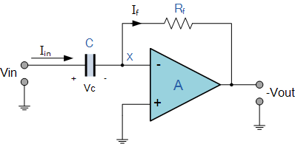

**VERIFICATION:**

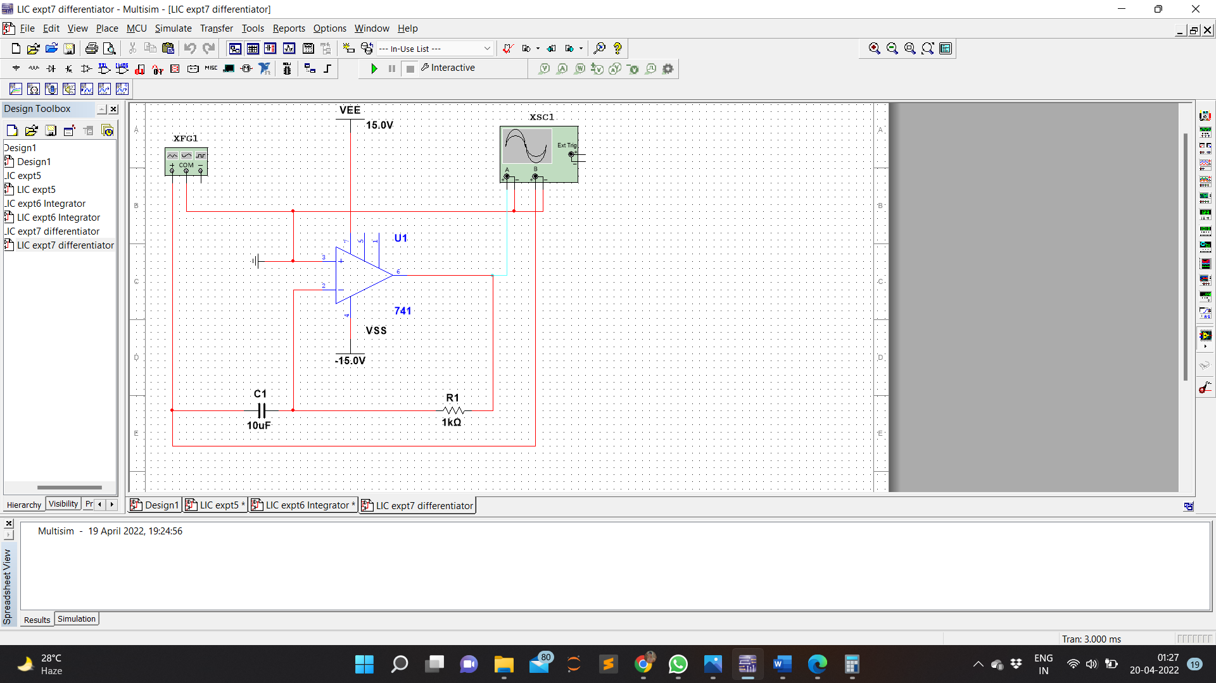Circuit Diagram

Input Voltage

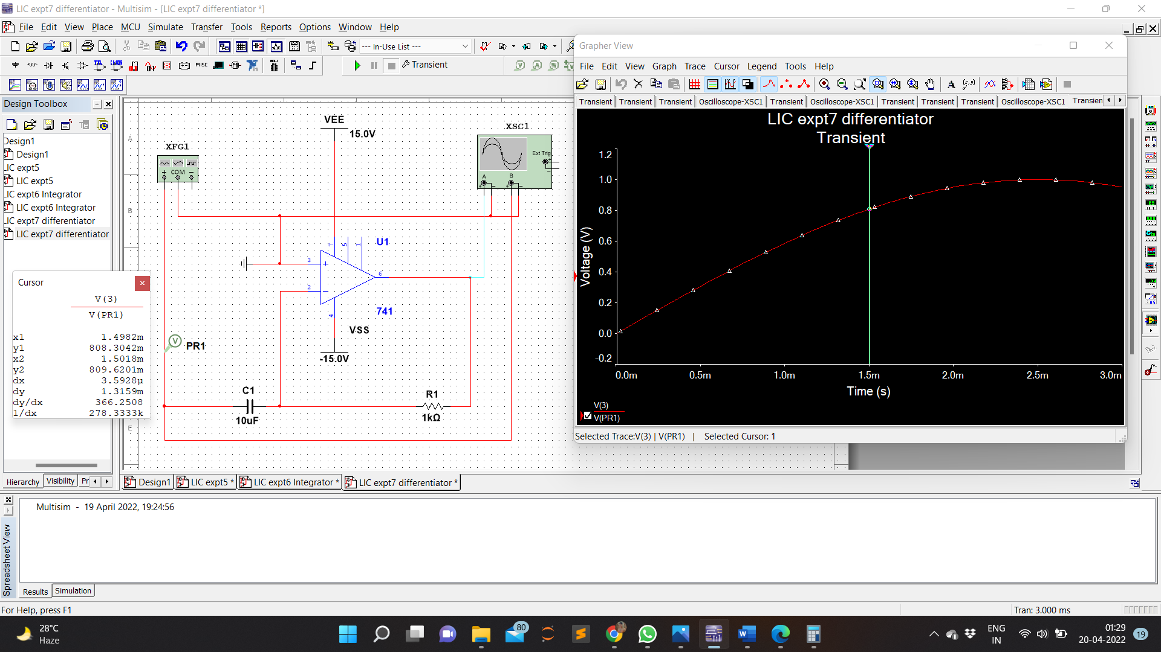

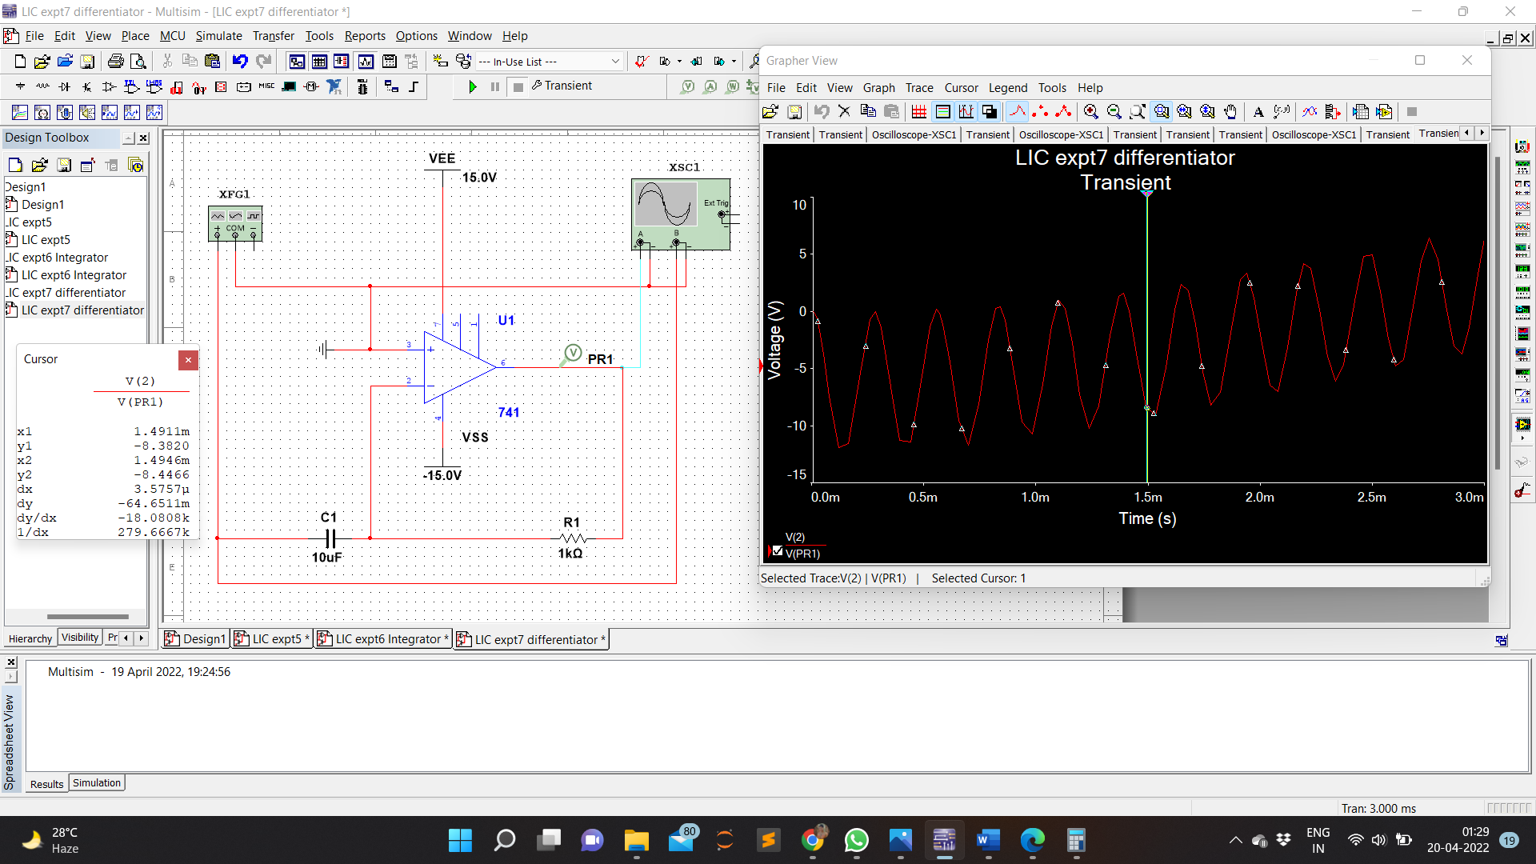Output Voltage

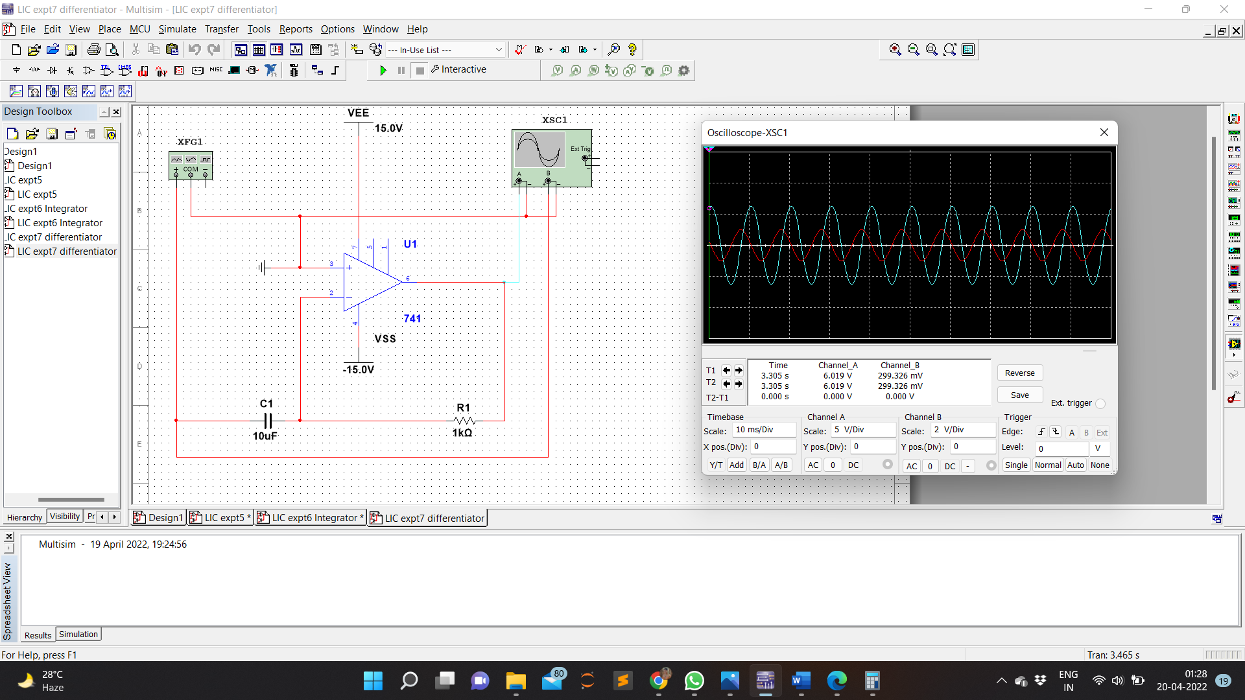Waveform

Calculation

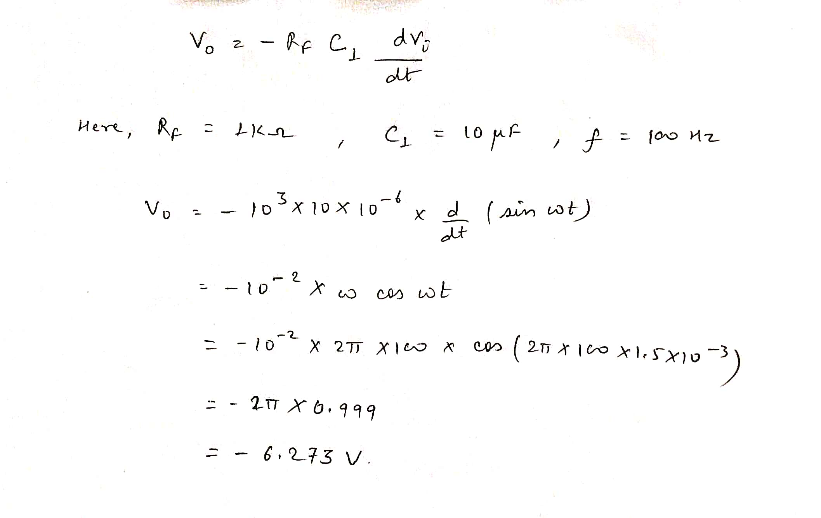

**RESULT:**

Differentiator was designed using multisim , simulated and verified